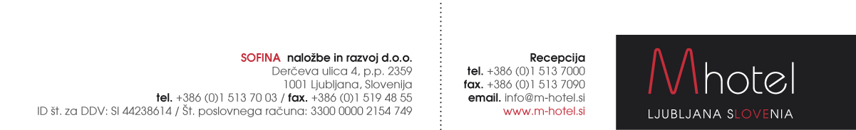

**HOTEL RESERVATION FORM**

**»IOBC 2017 – Ljubljana« (2.7. – 5.7.2017)**

Reservations to be sent to the following e-mail address: [anja.novak@m-hotel.si](mailto:anja.novak@m-hotel.si)

|  |  |
| --- | --- |
| **First and last name:** |  |
| **Arrival date:** |  |
| **Departure date:** |  |
| **Room type and no. of persons** |  |
| **Phone no.** |  |

|  |  |
| --- | --- |
| **RATES WITH BREAKFAST:**  **Single room:**  **Single room Superior:**  **Double room:**  **Double room Superior:** | **65 EUR / night.**  **80 EUR / night.**  **76 EUR / night.**  **90 EUR / night.** |

Tourist tax supplement: 1,27 EUR / person / night. Halfboard suplement: 12 EUR

All the modern rooms are with free wireless Internet, minibar, hairdryer, direct dial phone. Very comfortable mattresses from the latoflex.

Limited number of the rooms available. Reservation deadline until 2.6.2017

**Payments:** at the hotel.

**M hotel offers you a transfer service from/to the following airport:**

|  |  |  |  |  |  |  |  |  |  |  |  |  |
| --- | --- | --- | --- | --- | --- | --- | --- | --- | --- | --- | --- | --- |
| |  |  |  |  | | --- | --- | --- | --- | |  | NUMBER OF PERSONS | | | |  | Up to 4 |  |  | | DR. JOŽE PUČNIK LJUBLJANA AIRPORT – M HOTEL | 30,00 EUR |  |  | |

The driver will pick you up at the airport with a sign with your name on it.

Payment: directly to driver.

IN CASE YOU NEED OUR TRANSFER SERVICE PLEASE FILL IN YOUR FLIGHT DETAILS:

ARRIVAL DATE:

ARRIVAL TIME:

FLIGHT NUMBER:

NUMBER OF PERSONS:

**Welcome to M hotel!** [www.m-hotel.si](http://www.m-hotel.si)

